ThE Sun Inn
To start
Homemade soup of the day –
Chef’s freshly made soup served with fresh crusty bread (see special’s board) £5.50
Garlic & chilli prawns- Tiger prawns cooked in garlic & chilli butter served with fresh
crusty bread £ 6.95
Creamy garlic mushrooms- Sautéed in garlic butter finished with cream and served with
fresh crusty bread £ 5.95
The Sun Inn's special scallops £ 7.25
Homemade chicken liver pate- Chef’s smooth chicken liver pate served with chutney
and whole grain toast £ 5.95
Moules marinieres- Mussels in a garlic, onion, white wine and parsley sauce served with
fresh crusty bread £7.50
Grilled goat's cheese salad- Served with fresh crusty bread £ 5.25

Mains
Homemade steak and ale pie- Succulent pieces of beef steak with rich Robinson’s ale
gravy, topped with a puff pastry lid and served with fresh seasonal vegetables and a
choice of potatoes £10.95
Fish & Chips- Freshly beer battered cod served with chips and either mushy or garden
peas £10.50
Wholetail breaded scampi- Deep fried to perfection served with chips and garden or
mushy peas £10.50
Homemade chilli con carne- Spicy minced beef, peppers and kidney beans in a rich
tomato sauce served with boiled rice, nachos and soured cream dip £9.75
Homemade chicken curry- A medium spiced curry with tomatoes and onions served
with rice, chips or ½ & ½ and mango chutney £10.50
Add a naan bread £1.00
Welsh lamb rump- Served with rosemary jus, mashed potatoes & veg £15.95
Sirloin Steak (8oz)- With sautéed mushrooms, battered onion rings, grilled tomato and
served with chips and salad or vegetables £17.50
Rib eye steak (8oz)- With sautéed mushrooms, battered onion rings, grilled tomato and
served with chips and salad or vegetables £18.50
10oz prime gammon steak- served with grilled pineapple, a fried egg, chips and salad or
vegetables £12.50

Classic Beef Burger- Local Welsh beef burger grilled to perfection in a bun with burger
relish, served with chips and salad £9.50
add cheese, stilton or crispy bacon £1.50
The Sun Burger- Local Welsh beef burger served in a bun with bacon, mozzarella,
jalapeños and Cajun & chilli mayo. Served with chips and salad £11.50
The Ranch Burger Local Welsh beef burger served in a bun with bacon, mozzarella,
onion rings and barbeque sauce. Served with chips and salad £11.50
Butternut squash, beetroot and roasted red onion lasagne Served with chips and salad £10.50
Macaroni Cheese- Freshly made with a rich cheese sauce served with chips and salad £ 8.75

Extras & Side Orders
Garlic Bread £2.00
Garlic Bread with cheese £2.50
Battered onion rings £3.25
Chips £2.90
Fresh seasonal vegetables £2.95
Side salad £2.95

Children’s Meals (for under 12’s)
Chicken bites with chips and peas or beans
Sausages with chips and peas or beans
Fish & Chips with peas or beans
Burger with chips and peas or beans
Spaghetti Bolognese
Macaroni Cheese all at £6.75

Please place your order at the till in the dining room. Thank you.
We believe in supporting local suppliers and producers whenever possible to ensure full traceability from the farmer’s gate to your plate.
Ffrwythau D.J. Fruits, Harlech Food Service, Nicol Hughes & local fishermen
.

STAFF GRATUITIES ARE NOT INCLUDED IN OUR PRICES
Allergy Advice: All our food is prepared in a kitchen where nuts, gluten & other allergens are present and our menu descriptions do not include all ingredients – if you have a food allergy, please let us know before ordering.
Full allergen information available.

Sandwiches, Toasties & Baguettes (only available from 12pm – 2pm)

Sandwich Baguette
Ham £5.50 £6.00
Cheese £5.00 £5.50
Cheese & Tomato £5.50 £6.00
Hot Beef & Onion £6.00 £6.50
Sausage & Onion £6.00 £6.50
Bacon & Brie £6.50 £7.00
Tuna Mayonnaise £5.50 £6.00
Prawns in Marie Rose Sauce £6.00 £6.50

Light bites (only available from 12pm – 2pm)

Cheesy Nachos served with Sour Cream & Salsa £5.50
Chilli Beef Nachos topped with Cheese served with Sour Cream & Salsa £7.25
Ham, Egg & Chips £7.75

Jacket Potatoes

Cheese £5.50
Beans £5.50
Cheese & Beans £6.00
Chilli £6.50
Chilli & Cheese £6.75
Tuna Mayonnaise £6.00
Prawns in Marie Rose Sauce £6.95

John, Viv, Stephen & Manon
Yn eich croesawu / Welcome you
Tafarn yr Haul – The Sun Inn
Llanengan

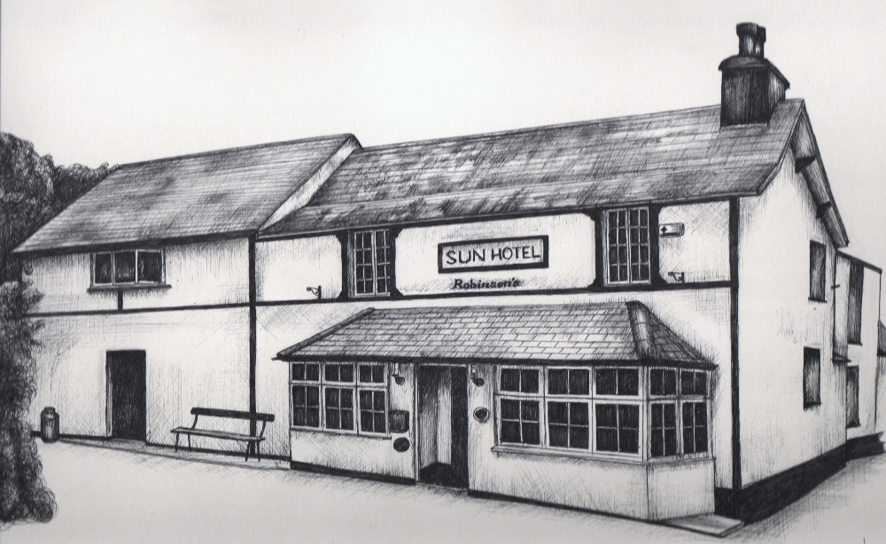
Nid ydym yn gweini bwyd sydyn, ond gweini’r bwyd goraumor gyflym ag y medrwn!
We do not serve fast food, we only serve the very best of foods as fast as we can!

Ffon /Phone 01758 712660
Symydol / Mobile 07909922571
e-bost / e-mail yrhaul@hotmailm.com
www.thesuninnllanengan.co.uk

Staff Gratuities are not included in our prices

